
tM-7520A Series Quick Start
v1.0, December 2022

Packing List
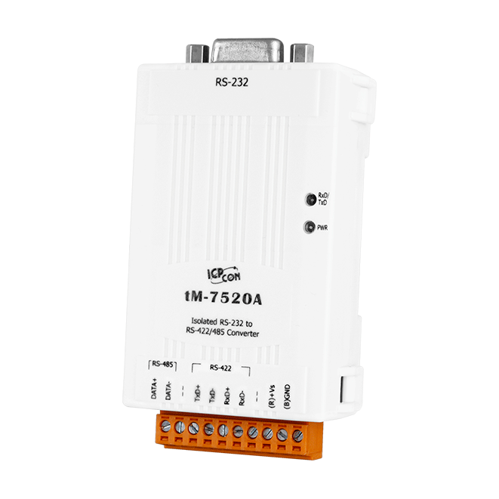
In addition to this guide, the package includes the following items:
tM-7520A

Technical Support  service@icpdas.com  www.icpdas.com | Resources  How to search for drivers, manuals and spec information on ICP DAS website.  - For Mobile Web  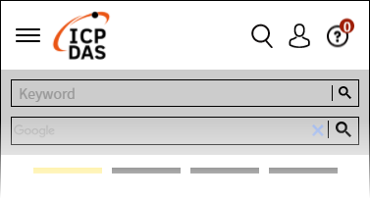  Model Name


- For Desktop Web
Model Name

Wire Diagram

1) Connect both the tM-7520A and your PC with RS-232 cable.
2) Connect both the tM-7520A and your Devices with RS-485 cable.
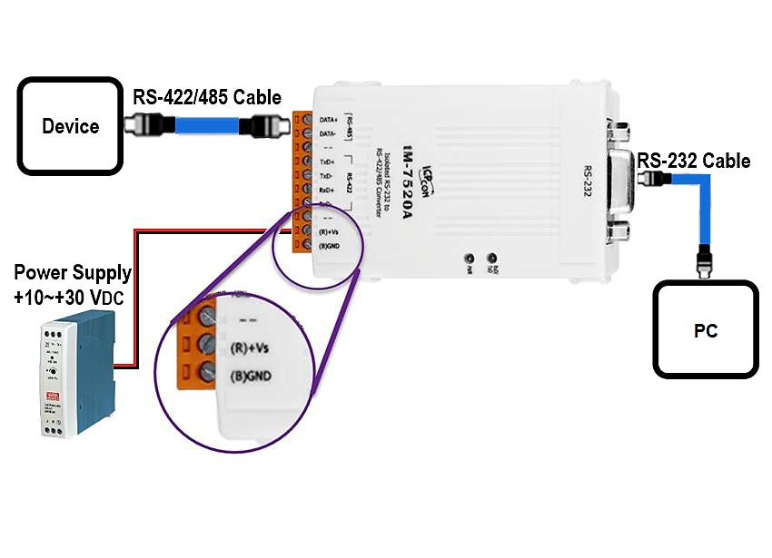
3) Supply power (+10~+30 VDC) to the tM-7520A.

