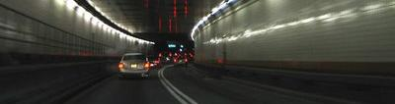
Coping With Traffic Accidents through the Net!

Emergency Warning System with ET-7000 Series Web Based I/O Modules

Tunnel safety has been regarded as a key roadway safety issue. The consequences of tunnel accidents tend to be much more serious because of the enclosed space, poor lighting, rapid expansion of heat and smoke, and the more complicated evacuation procedures. The worst thing is that sometimes the drivers do not know what happens in the tunnel and keep on moving into it; the lack of real-time access control results in difficulty in evacuation and delay on rescue. To help reducing the risk of accidents in tunnels - especially for long tunnels, it is critical to have a well designed emergency warning system that provides real-time monitoring and access control.

The ET-7000 series web based I/O modules launched by ICP DAS have been used in traffic control systems in many countries, owing to the immediate and long-distance transmission by Ethernet. The Emergency Transmitters equipped with ET-7000 modules are established every 200 feet in these tunnels. At the time emergency occurs, drivers could press the button of the closest transmitter and the ET-7000 module will receive the message and send the emergency information to the central control room trough the Ethernet, showing the location of emergency immediately. The central control room can monitor the situation of the tunnel through web HMI instantaneously. Besides, administrators can also send orders to all the other ET-7000s in this system, commanding the ET-7000s to turn on the alarms installed in the transmitters.

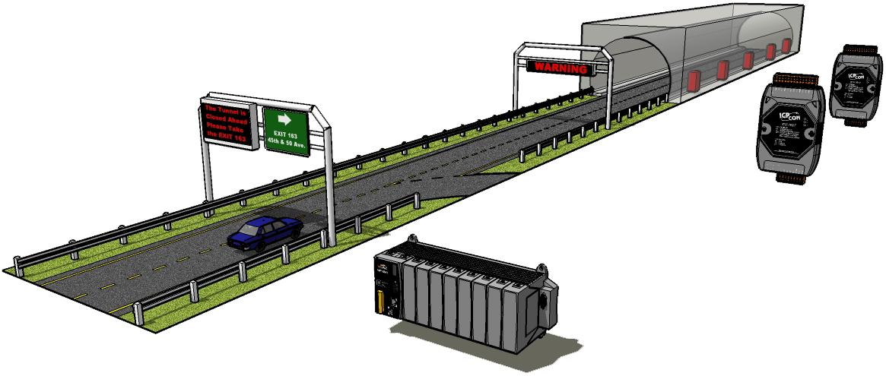
PAC
ET-7000
Warning/Alarm
Display
Transmitter
Control Room
DI/O
DO
Ethernet
Remote DO Device
RS-232
Ethernet Switch

Furthermore, ET-7000 has a function that can create a DI to DO pair connection though the Ethernet. It can let remote DO devices to receive DI signals from ET-7000 modules. In this case, the DO module established at the entry of the tunnel will get the message of emergency and turn the warning lights on. This function can also be used for controlling the turntable of the camera and making the cameras to capture the frames of the spot precisely.

A web-based PAC is also assembled at the interchange in front of the tunnel. The emergency message will also be sent to this PAC, and the PAC will show the information on the LED display through RS-232, warning the drivers to keep away from the tunnel and to leave the highway right away, in order not to interrupt the operations of evacuating and rescuing.

Selection Guide of ET-7000 Series Remote I/O Modules:
http://www.icpdas.com/products/Remote_IO/et-7000/et-7000_selection_guides.htm

